A

Winter Report On

### A study on Factors Affecting Purchase of Frozen Food in surat city.

Submitted for the partial fulfillment of the degree

Bachelor of Business Administration (BBA)

### Submitted by

Baidingwala yash devendrabhai

Roll no. 05

T.Y. B.B.A (Marketing)

Under the guidance of

Prof. Vidihi joshi

SARVAJANIK EDUCATION SOCIETY

SHRI SHAMBHUBHAI V.PATEL COLLEGE OF BUSINESS ADMINISTRATIONVEER NARMAD SOUTH GUJARAT UNIVERSITY

Academic Year 2022-2023



### ACKNOWLEDGMENT

I would like to thank to **Veer Narmad South Gujarat University** to include this Winter Project in the curriculum of B.B.A program. And I would like to thank my college

**S.V.PATEL COLLEGE OF BUSINESS ADMINISTRATION** for providing me such an opportunity to receive training to esteemed organization as the part of BBA program. B.B.A.is a course which is especially designed to meet need of the demanding world one has to be sharp, convincing, processing, good managerial skill, smart and talented to face the on-demand world. As part of curriculum student of 6th Semester B.B.A. has to do training in a well-managed industry and then to prepare project on it, which presents a full overview of the business concern.

I would like to record my special thanks to my parents, friends and colleagues help me directly or indirectly in preparation of project work. I am sincerely thankful to all the faculty member of BBA department who directly or indirectly supported me during the project.

Yash Baidingwala

**T.Y.B.B.A (Marketing) Roll. No: 05**

### DECLARATION

I, yash baidingwala hereby declare that the project report entitled “To study on Factors Affecting Purchase of Frozen Food in surat city” under the guidance of PROF.vidihi joshi, submitted in partial fulfilment of the requirement for the award of the degree of Bachelors of Business Administration to Veer Narmad south Gujarat university, Surat is my original work - research - study carried out during sixth semester (2021-22) and not submitted for the award of any other degree of any other institution I organization of University

Yash Baidingwala

T.Y.B.B.A.Markting Roll no.: 05

Signature: Date: 24th fab, 2023

### EXECUTIVE SUMMARY

This project has been submitted to fulfill the requirement of my college in BBA program of VNSGU. The objective of the project report is to do “To study on Factors Affecting Purchase of Frozen Food in surat city.”. This report is prepared with the help of primary and secondary data. Primary data was collected by direct google form with the help of questionnaire. Secondary data was collected from the internet, books & previous research.

This report includes six chapters:

So this first very chapter contains introduction of my research topic. Factors Affecting Purchase of Frozen Food..

The second chapter is literature review. In this second chapter you will find insightful different- different research paper’s brief summary.

The third chapter is research methodology. Research methodology provides information about sample size, sample design, sample unit, research instruments being used, target population, types of data, research objectives, research designs and data collection methods.

The fourth chapter is data analysis. all the collected information is analyzed through SPSS, MS Word, MS Excel and all the collected information is shown through bars graphs, pie charts, frequency tables..

The fifth chapter is findings. It shows the overall conclusion about my report.

The last chapter is Bibliography. It shows the all references of used data and link to access original data.

|  |  |  |
| --- | --- | --- |
|  | **INDEX** |  |
| **SR NO.** | **PARTICULAR** | **PAGE NO.** |
|  | Acknowledgement | I |
|  | Declaration | II |
|  | Executive summary | III |
| **CH 1** | **INTRODUCTION** |  |
| 1.1 | About frozen food | 2 |
| 1.2 | Factors which affect | 2 |
| 1.3 | History | 4 |
| 1.4 | Major Market Player in Frozen Food Business | 5 |
| 1.5 | Benefits of Frozen food | 8 |
| **CH 2** | **LITERATURE REVIEW** |  |
| 2.1 | Literature Reviews | 10 |
| **CH 3** | **RESEARCH METHODOLOGY** |  |
| 3.1 | Research Objectives | 15 |
| 3.2 | Research design | 15 |
| 3.3 | Source of data | 16 |
| 3.4 | Population | 17 |
| 3.5 | Sampling | 17 |
| 3.6 | Data collection | 18 |
| 3.7 | Data collection methods | 19 |
| 3.8 | Data analysis | 19 |
| 3.9 | Limitation of study | 19 |
| 3.10 | Scope of future study | 20 |
| **CH 4** | **DATA ANALYSIS** |  |
| 4.1 | Data Interpretation | 22 |
| **CH 5** | **MAJOR FINDINGS** |  |
| 5.1 | Conclusion | 44 |
|  | **BIBLIOGRAPHY/ REFERENCE** | 45 |
|  | **ANNEXURE** | 46 |

# CHAPTER 1: INTRODUCTION

## Introduction to topic

* 1. **Frozen food**, any of the complete meals or portions of meals that are precooked, assembled into a package, and frozen for retail sale. They are popular among consumers because they provide a diverse menu and are convenient to prepare. A frozen prepared meal may contain a meat entree, a vegetable, a starch-based food such as pasta, and sauce. Some frozen meals are prepared specifically for vegetarians or for individuals with certain dietary needs. The manufacture of such a product requires careful attention by the food processor.
  2. **Factors which affect** the most to the customer to buy a frozen food product
     + Gender, age, occupation, income and education are some common factors but there are some various factors which have some major effect towards buying product such as**: Easy to cook, packaging, Low price, Taste, Quality, Time saving, Appearance, Availability.**
     + Here I differ two types of factors . in which I mentioned some factors as ex.
* **Intrinsic** – Taste, ingredients, nutritional value, overall quality, value for money
* **Extrinsic**- Brand, advertisement, convenience, knowledge etc.

#### Time Saving:

Convenience/ frozen Food helps reduce the time required for pre- preparation and to some extend even cooking time required. Hence, significant time can be saved where preparation from scratch for any meal can be avoided.

#### Variety:

Due to the various techniques used in the convenience food manufacturing process one is able to get a lot of variety in the market. In fact the amount of variety available in the stores today does put a working woman in a fix on the choice that she needs to make. Another point to be noticed is that this variety remains constant in the market and does go off shelf citing seasonal reasons like the fresh fruits and vegetables do.

#### Healthy:

One can read the contents and detailing on the packaging of the convenience product and decide to whether heath aspects are preferred or not.

#### Convenience:

These products are convenient to carry, stack and store them since their packaging are well planned considering various factors like consistency, texture, size and fragility. Shelf Life: Most convenience foods have a longer shelf life due to additives and the same is also mentioned on the package hence the user well informed of its usage period.

#### Storage:

Storage of convenience foods is easy as they can be stacked up anywhere and can also help better utilization of the space available. Regeneration is also faster and better.

#### Availability:

Certain fresh products might not be available throughout the year due to their seasonal availability whereas convenience products are

manufactured using stringent quality standards hence their availability besides being consistent also has consistent taste, texture and taste

#### Food Safety:

The new techniques used in the manufacturing and packaging of convenience like aseptic canning, rapid freezing, various methods of eradicating bacteria reduce sits presence and also reduces spoilage of food to a great extent if stored properly.

* 1. **History**

Since early times, farmers, fishermen, and trappers have preserved grains and produce in unheated buildings during the winter season. Freezing food slows decomposition by turning residual moisture into ice, inhibiting the growth of most bacterial species. In the food commodity industry, there are two processes: mechanical and cryogenic (or flash freezing). The freezing kinetics is important to preserve the food quality and texture. Quicker freezing generates smaller ice crystals and maintains cellular structure.

Preserving food in domestic kitchens during modern times is achieved using household freezers. Natural food freezing (using winter frosts) had been in use by people in cold climates for centuries.

In 1861 Thomas Sutcliffe Mort established at Darling Harbour in Sydney, Australia, the world's first freezing works, which later became the New South Wales Fresh Food and Ice Company. Mort financed experiments by Eugene Dominic Nicolle, a French born engineer who had arrived in Sydney in 1853 and registered his first ice-making patent in 1861. The first trial shipment of frozen meat to London was in 1868. Although their machinery was never used in the frozen meat trade.

By 1885 a small number of chickens and geese were being shipped from Russia to London in insulated cases using this technique. By March 1899, the "British Refrigeration and Allied Interests" reported that a food importing business, "Baerselman Bros", was shipping some **200,000** frozen geese and chickens per week from three Russian depots to New Star Wharf, Lower Shadwell, London over three or four winter months. This trade in frozen food was enabled by the introduction of Linde cold air freezing plants in three Russian depots and the London warehouse.

From 1929, Clarence Birdseye introduced "flash freezing" to the American public. Birdseye first became interested in food freezing during fur-trapping expeditions to Labrador in 1912 and 1916, where he saw the natives use natural freezing to preserve foods. The Icelandic Fisheries Commission was created in 1934 to initiate innovation in the industry, and encouraged fishermen to start quick-freezing their catch. Other experiments involving orange juice, ice cream and vegetables were conducted by the military near the end of World War II.

### Major Market Player in Frozen Food Business

The frozen food market is estimated to account for about USD **244.3 billion** in 2020 and is projected to reach a value of about **USD 312.3 billion by 2025**, at a CAGR of 5.0%. Developments in the retail landscape, rising demand for convenience food, and technological advancements in the cold chain market are the major driving factors for the market. On the other hand, the rising preference for fresh and natural food products is a restraining factor for the frozen food market.

Currently, the frozen foods market in India is about Rs 7,400 crore and it is growing at about 17 per cent annually.

#### ITC

* + The company, which has recently made a foray into the frozen food segment under ITC Master Chef brand targeting both retail and food

services players, is also planning to expand its reach to over 30 cities in the retail segment and 100 cities in food services segment during the period. Company’s intention is to explode the category. they are doubling their volumes. growth rate of company is about 6-7 times the industry growth," - Frozen Snacks, Fruits and Vegetables At present, depending on outlets and range, ITC's current market share will vary from 5-15 per cent in the segment.

#### KOHINOOR

* + he newly-formed 85:15 joint venture between the NYSE-listed $3- billion (approximately 15,400 crore) firm and Kohinoor Foods, has identified cooking ingredients such as sauces, and convenience foods such as frozen foods, to launch its products.

#### AJINOMOTO

* + From Asian to Mexican to Italian, we are the brand leader among the largest categories of ethnic frozen foods, and across every distribution channel including foodservice, grocery, warehouse club, and custom manufacturing. A leader in the world of ethnic frozen foods and appetizers, Ajinomoto Foods North America was the first to market and sell frozen family favorites such as one-step potstickers, breaded mozzarella cheese sticks, and more.

#### McCain

* + McCain Foods Ltd. is the world's largest producer of French Fries and Potato Specialties. McCain Foods (India) is a 100% subsidiary of McCain Foods Canada. McCain Foods Ltd. is the world's largest producer of French Fries and Potato Specialities. McCain has grown to become a global leader in the frozen food industry. From Canada, across the world to Japan, from the tip of Argentina to suburbs in Australia, our tasty and convenient food products are served in restaurants and sold in retail stores; adding nutrition and flavour to family meals time after time.

#### NESTLE

* + Nestle SA is launching Life Cuisine, a new brand designed to “feed modern lifestyles,” the company said. The lineup includes frozen bowls, egg bites and pizzas that cater to four consumer preferences: high-protein, low-carb, meatless and gluten-free. Additionally, nestle is releasing more than 40 new and improved Lean Cuisine recipes debuting in updated packaging, including a new line of bowls. Twelve of the recipes contain 20% more food compared to similar previous offerings. Nestlé USA’s factory expansion could capitalize on the continued uptick in frozen food sales. Some of the most popular frozen food items during the pandemic included pizza (37%), vegetables (37%), entrees (27%) and poultry (26%), according to research from The Freedonia Group, which are all core offerings for Nestlé’s frozen food portfolio.

#### AMUL

* + The increased availability of frozen foods comes off the back of a spike in interest from consumers sparked by the Covid-19 pandemic.
  + Amul already has a cold-chain supply infrastructure in place for key products such as ice cream, making it easier for the firm to increase range of frozen foods.
  + Food industry analysts in India say that consumers are increasingly keen to buy branded packaged frozen foods at modest prices, whether they are frozen meals or single foods such as frozen potatoes.
  + Amul is the only player which has a well-established cold chain network with 66 depots and 2 lakh outlets from Leh-Ladakh to Kanyakumari and from Jaisalmer to Shillong. Frozen food products are already being consumed in India.

-

### Benefits of Frozen food

Fruits and vegetables are picked at peak ripeness and often frozen within hours, locking in nutrients and flavor. Generally, frozen foods retain their vitamins and minerals and there is no change to the carbohydrate, protein or fat content. In some cases, frozen foods have more vitamins and minerals compared to fresh because fresh foods lose vitamins and minerals over time while freezing preserves nutrients.

Frozen foods can be a convenient and affordable way to incorporate healthful foods from every food group, including whole grains, fruits, vegetables, protein and dairy. In addition to a time-saving convenience, frozen foods can be a benefit for individuals with limited kitchen space or utensils. Not only can frozen foods be more affordable in price, but they also can aid in reducing food waste.

The frozen food industry is growing rapidly and creating enormous opportunities for investors Similarly, Solanki and Sheth (2015) found that frozen food industry of India was growing at the fastest pace of 30% per year. In India, there are more than 100 international, national, and local producers of frozen food in the industry, and the same number of players are expected to enter into the market in the coming year. This growth has led marketers to identify factors behind the consumers' intent to purchase frozen food.

But, The knowledge about food nutrition was closely related to food purchase, but at the same time, many studies reported that frozen food purchase was not related with the knowledge level of the customers.

# Chapter 2: Literature review

|  |  |
| --- | --- |
| **Topic**  **:** | **The Analysis of Factors Affecting the Buying**  **Interest in Poultry Frozen Food Processed Product** |
| **Name of the author :** | **Ratna Purwaningsih, Novie Susanto, Natalia Purba,**  **and Ade Aisyah Arifna Putri** |
| **Name of journal or article Indian Journal of**  **Marketing** | **the International Conference on Industrial Engineering and Operations Management** |
| **Year of publication :** | **April 2021** |

-According to the findings of factor analysis, there are six factors of buying interest derived from 16 indicators, with five indications demonstrating no significant association to all factors. The product's marketing mix (product features, price, promotion, and distribution), the psychological factor, and the social element are the factors. Indicators with a high degree of association These indicators are affecting the purchase interest, according to the factors from factor analysis.

Nutritional content and halal food label are two indications that have a strong link to product qualities. All Price, promotion, and distribution factor indicators all have a strong relationship with their respective factors. All The parameters have a significant link with psychological signs. The product's social factors suggest that it's a good product information obtained from co-workers and friends.

|  |  |
| --- | --- |
| **Topic**  **:** | **Consumer’s Motivation to Purchase Frozen**  **Food in Kathmandu** |
| **Name of the author :** | **Sunita Dabadi, Binit Gurung** |
| **Name of journal or article Indian Journal of**  **Marketing** | **Management Dynamics,** |
| **Year of publication :** | **2020** |

-The researcher investigated socio-economic characteristics (age, gender, employment position, and education), as well as numerous intrinsic aspects and intrinsic factors, in

order to determine customer purchase intention for ready-to-eat meals. The findings of the study show that both motivation factors play a significant role in purchase intention. The study also shows that purchase intention is influenced by age, employment status, and educational status. Furthermore, the current study found a strong association between motivation factors and buy intention; however, the study found no significant relationship between age, gender, or work position and purchase intention. In contrast to what the study revealed, According to the findings, the majority of intrinsic and extrinsic factors had a favourable impact on customers' willingness to buy frozen food, depending on the Taste and value.

|  |  |
| --- | --- |
| **Topic**  **:** | **Determinants of Frozen Food Purchase Intentions :**  **Insights from a Developing Country** |
| **Name of the author :** | **Muhammad Abid Saleem,Allah Wasaya, Sadaf**  **Zahra** |
| **Name of journal or**  **artical** | **Indian Journal of Marketing** |
| **Year of publication :** | **July 2017** |

-The study reveals that all of the hypotheses are valid, and prior studies in the same field have yielded comparable results. This research backs up previous research that found a link between frozen food knowledge, change seeking personality traits, and frozen food purchase intentions. The research adds to the expanding body of knowledge.Companies should be aware that their strategy may need to be adjusted based on their customers' knowledge of frozen foods.as well as their psychological characteristics Because of fluctuating socio-demographic factors in metropolitan regions of South Punjab, Pakistan, two alternative family configurations were chosen for comparison in this study. The results show that the The emergence of a nuclear family system is a key signal.aims and stance on frozen foods,

|  |  |
| --- | --- |
| **Topic**  **:** | **Factors influencing consumers' to Take Ready-**  **made Frozen Food** |
| **Name of the author :** | **Shuvro sen** |
| **Name of journal or article Indian Journal of**  **Marketing** | **Springer** |
| **Year of publication :** | **February 2019** |

-The purpose of this study was to discover why people choose ready-made frozen foods. Consumer purchase intent has been shown to be influenced by socio- demographic parameters such as age, gender, education, income, and other aspects in previous studies. Because a favourable attitude and purchase intention do not always translate into real purchasing behaviour, the impact of socio-demographic factors is also investigated. The findings demonstrated that socio-demographic factors such as gender, age, education level, family income, and occupation have an impact on RMFF purchases. Working women, more than any other age group, are the primary purchasers of this food, according to the findings. However, educational attainment and family income have a substantial impact on purchasing decisions.

|  |  |
| --- | --- |
| **Topic**  **:** | **FROZEN FOOD REVOLUTION: INVESTIGATING HOW AVAILABILITY OF FROZEN FOOD AFFECTS CONSUMER**  **BUYING BEHAVIOR INTRODUCTION** |
| **Name of the author :** | **Nawaz Ahmad** |
| **Name of journal or**  **article Indian Journal of Marketing** | **International Journal of Economics, Commerce and Management** |
| **Year of publication :** | **August 2014** |

-In this study, the statistical analysis revealed H1to be accepted and H1to be rejected, indicating that frozen foods have an impact on purchasing behaviour, as evidenced by Karl Pearson's coefficient and the standardised coefficient during the ANOVA analysis, which both showed a value of 0.00 and a beta value of.522+, indicating that frozen foods have a 52.2 percent chance of being purchased. There is also a positive association between the two variables, such that if frozen food awareness or any other factor rises, it will have a beneficial impact on purchasing decisions. it is proven that people tend to go for frozen foods due to the multiple diseases and health risks present. it is proven that people tend to go for frozen foods due to the multiple diseases and health risks present In the world and also due to the

availability and ease of use of frozen foods are one on f the variable that are increasing buying behavior towards frozen foods as well as frozen vegetables.

# Chapter 3: Research Methodology

## 3 Objectives

#### Primary Objective

To study on Factors Affecting Purchase of Frozen Food in surat city.

#### Secondary Objectives

* + - 1. To identify factors influencing to buying behavior towards Frozen Food.
      2. To evaluate brand preference of the consumers.
      3. To study the factors influencing brand preference.
      4. To analyze which are the most preferred frozen food products.
  1. **Research design**

Research design refers to the framework of [market research methods](https://www.voxco.com/market-research-tools/) and techniques that are chosen by a researcher. The design that is chosen by the researchers allow them to utilise the methods that are suitable for the study and to set up their studies successfully in the future as well.

#### Exploratory research design

it is defined as research used to investigate a problem. Which is not clearly define. It is conducted for a research problem when the researcher has no past data or only a few studies for reference. It will not offer concrete solutions for the research problem. It is conducted to have a better understanding of the existing problem. But will not provide conclusive result, research starts with general idea. It identifies problems. Problem is in a preliminary stage.

Exploratory research requires the researcher to investigate different sources such as published secondary data, data from other surveys, observation of research items, and opinions about a company, product, or service.

#### Descriptive research design

In this in-depth description of the phenomenon or population under study. This methodology focuses more on the what of the research subject. Trends in particular field or the frequency of an event.

* + - 1. **Cross-Sectional Survey**: Cross-sectional surveys are a kind of survey where standardised data is collected from a cross-section of the pre-determined population at a given point in time.
      2. **Longitudinal Survey:** Longitudinal surveys are used in longitudinal studies where the same variables are observed over a long period of time. This allows researchers to investigate the status of variables at different points in time.

#### Casual research design

A research method used to determine the cause-and-effect relationship between two variables.

In this study, Exploratory research design is used because it is existing study and few past studies are also included for reference.

### Source of data

#### Primary data:

Data that has been generated by the researcher himself/herself, surveys, interviews, experiments, specially designed for understanding and solving the research problem at hand.

The researcher has collected the data through the customer with the Questionnaire.

#### Secondary data:

Secondary data means data collected by someone else earlier or

Hence the Secondary data is collected from research paper and journal articles available on the internet etc.

### Population

A sample is a random selection of members of a population. It is a smaller group drawn from the population that has the characteristics of the entire population.

The target population for this research are the citizens of the Surat city Who use OTT platform, as the purpose of research is to understand the preference of OTT among the people of Surat city. Population includes people of various age group, genders, individual income and backgrounds.

* 1. **Sampling**

#### Sampling frame

In this research Student, employee, teenage, Businessman, retired people and house – wife a sampling frame is a database of potential respondents that can be drawn from to invite to take part in a given research project.

#### techniques

* + - 1. **Probability Sampling Methods**

Probability sampling refers to the selection of a sample from a population, when this selection is based on the principle of randomization, that is, random selection or chance. Probability sampling is more complex, more time-consuming and usually more costly than non-probability sampling

#### non-probability samples

Non-probability are cases where you do not know of every unique member of the population in question (i.e., the entire user group in our case). Another way to describe it is when every member of the population *does not* have an equal chance of being invited to participate. Probability samples are when you do know of every unique member of the population and therefore each has a probabilistic chance of being invited for the sample.

#### Convenience sampling

Convenience sampling involves using respondents who are “convenient” to the researcher. Using random numbers to pick potential respondents or participants from a sampling frame

In this survey convenience sampling use because participants are selected based on availability and willingness to take part.

#### sample size

refers to the number of participants or observations included in a study. sample size for this research is 200 respondents from Surat city.

### Data Collection

#### Type of data

* + - 1. **Primary data**

Primary data are original observation collected by the researcher or his agents for the first time for any investigation and used by them in the statistical analysis. i have collected primary data through questionnaire.

#### Secondary data

Any data which has gathered earlier by some other person are secondary data. Secondary data are collected by other and used by others. I have also taken data through different websites , journals and books.

#### 3.6.1 Instrument used

The research instrument used for collecting primary data. In the questionnaire questions are asked according to topic and also of different types of questions are there like multiple option questions, scaling question, check boxes.

### Methods

* observation
* Survey

- I have used survey method. It is personal survey method by which I collected data by filling up questionnaire. I had used structured questionnaire for this research.

### Data Analysis

#### Tools and Techniques

* Data analysis has been performed for the data collected from the respondents using the questionnaire.
* To analyse the data, I have used frequency method, various graphs and charts. (Pie- charts, bar graph)
* Data analysis tools such as excel and SPSS were used.

### Limitation

1. Within the given time frame, survey was conduct among only 200 people. Which is not enough to justify the conclusion of a valid research result.
2. As the study was conducted with a few constructs, it is possible that a number of exogenous variables may not have been considered, and which could possibly have an influential impact on the dependent variable.
3. Location was another factor, Due to time constraints , the data was collected only from customers of limited area And Due to the varying socio-

demographics and culture of the country, the study may have different findings if data is collected from a balanced mix of all major cities. in terms of research scope as the topic being a really vast one the survey only was focused in the various super markets of in Surat.

### Scop of future study

The data was collected from regions like Piplod area, Adajan and Athwagate Area of Surat city, and thus the study can be conducted over same research topic in other areas of Surat or a study can also be conducted covering each area of Surat. The survey included 210 respondents because of time and cost constraints and thus there is scope for surveying more respondents for better inferences. The study can be conducted using other methods such as mail panels or computer aided surveys. The other data collection tools can also be used for better and sufficient data.. The study can be conducted for a longer time period then the time taken for this study.

# Chapter 4:

Data Analysis

### 4.1 Data Interpretation

#### Awareness among the people about the frozen food .

|  |  |  |  |  |  |
| --- | --- | --- | --- | --- | --- |
|  | | Frequency | Percent | Valid Percent | Cumulative  Percent |
| Valid | YES | 187 | 89.0 | 89.0 | 89.0 |
| NO | 23 | 11.0 | 11.0 | 100.0 |
| Total | 210 | 100.0 | 100.0 |  |

Table(4.1.1) Awareness

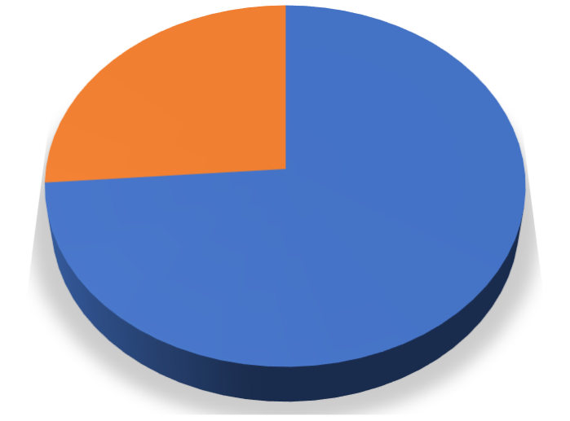

**26%**

**74%**

Purchased

Not purchased

Figure (4.1.1) The above chart represents awareness about frozen food.

#### Interpretation:

Following pie chart illustrates that majority of respondents are aware about any kind of frozen food, so that we can say that frozen food product are not newly product for the public. They were already hear about it from any kind of communication or word of mouth.

#### Number of people who bought frozen food or not.

|  |  |  |  |  |  |
| --- | --- | --- | --- | --- | --- |
|  | | Frequency | Percent | Valid Percent | Cumulative  Percent |
| Valid | Yes | 155 | 73.8 | 73.8 | 73.8 |
| No | 55 | 26.2 | 26.2 | 100.0 |
| Total | 210 | 100.0 | 100.0 |  |

Table(4.1.2) purchased frozen food or not

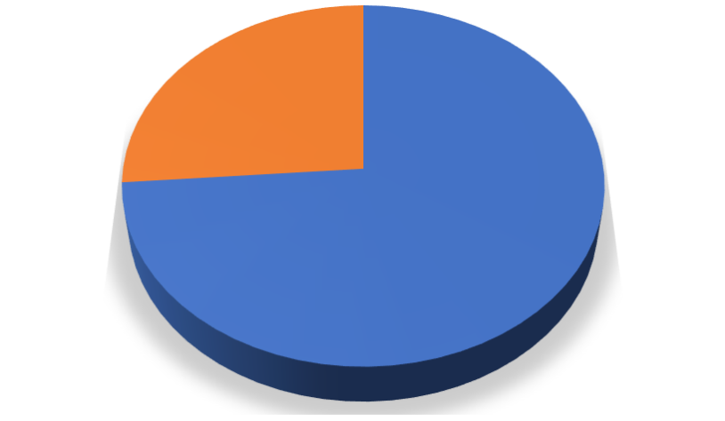

**26%**

**74%**

Purchased

Not purchased

Figure (4.1.2) The above chart represents number of buyer of frozen food

#### Interpretation:

From the above chart we can say that- it is much similar with previous response. Because of we can predicted that who have already heared about frozen food products they have purchased too. But there some loop hall as per my research because there are still ¼ people are not even purchased one time but now days people are more conscious than ever regarding to frozen food.

#### From where people got information of frozen food ?

|  |  |  |  |
| --- | --- | --- | --- |
|  |  | Frequency | Percent |
| Valid | Advertisement | 109 | 29.14439 |
|  | Social media | 108 | 28.87701 |
|  | Influencer | 75 | 20.05348 |
|  | Company’s website | 60 | 16.04278 |
|  | Friends | 1 | 0.26738 |
|  | Other | 21 | 5.614973 |
|  | Total | 374 | 100 |

Table(4.1.3) Source of information



Other

21

Friends 1

Company’s website

60

Influencer

75

Social media

108

Advertisement

109

0

20

40

60

80

100

120

Figure (4.1.3) The above chart represents from where people got information about frozen food.

#### Interpretation:

Chart implies that mostly advertisement and social media grabs attention very easily. it directly shows that many companies may spread information or choose the common

way to provide more information to the public. There are less number of word of mouth advertisement because out of 210 responders only 0.26% people hear about this product through their friends. People are also got the information from the company’s website.

#### Most preferred frozen food products by responders.

|  |  |  |  |
| --- | --- | --- | --- |
|  |  | Frequency | Percent |
| valid | Chicken lollypops | 35 | 8.816121 |
|  | Pizza | 104 | 26.19647 |
|  | Burgers | 64 | 16.12091 |
|  | French fries | 112 | 28.21159 |
|  | Breads | 62 | 15.61713 |
|  | Other | 20 | 5.037783 |
|  | Total | 397 | 100 |

Table(4.1.4)Most preferred frozen food product.

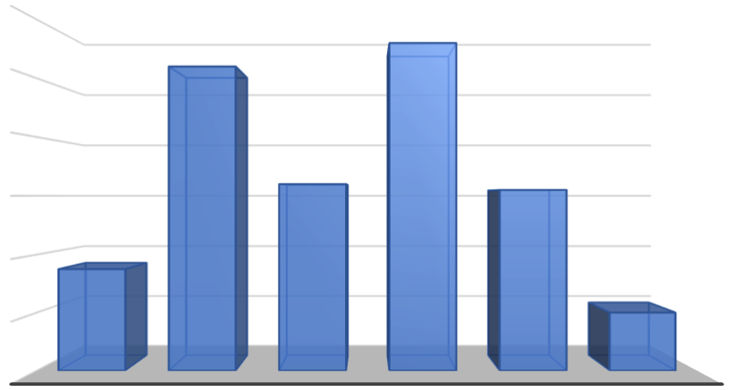

120

112

104

100

80

64

62

60

40

35

20

20

0

CHICKEN

LOLLYPOPS

PIZZA

BURGERS

FRENCH

FRIES

BREADS

OTHER

Figure (4.1.4) The above chart represents most preferred frozen food product.

#### Interpretation:

Following chart shows the most preferred frozen products are French fries and pizza. It should be same ration across the world because many resources provides more selling number. Since long time French fries have much popularity among the consumer. Still breads , chicken lollypops and some other products are getting growth in present.

#### Rate of the importance of Convenience which influences responders to buy frozen food.

|  |  |  |  |  |  |
| --- | --- | --- | --- | --- | --- |
|  | | Frequency | Percent | Valid Percent | Cumulative  Percent |
| Valid | Lowest | 70 | 33.3 | 33.3 | 33.3 |
| Low | 48 | 22.9 | 22.9 | 56.2 |
| Neutral | 39 | 18.6 | 18.6 | 74.8 |
| High | 27 | 12.9 | 12.9 | 87.6 |
| Higest | 26 | 12.4 | 12.4 | 100.0 |
| Total | 210 | 100.0 | 100.0 |  |

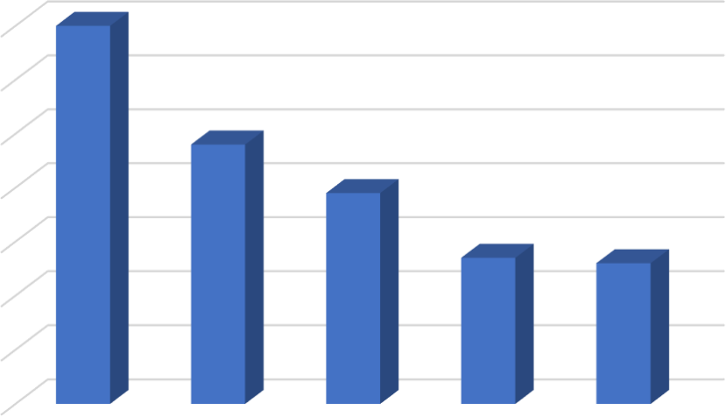Table(4.1.5) Importance of convenience

|  |  |  |  |  |  |
| --- | --- | --- | --- | --- | --- |
| 70 |  | | | | |
| 60 |  |  |  |  |  |
| 50 |  |  |  |  |  |
| 40 |  |  |  |  |  |
| 30 |  |  |  |  |  |
| 20 |  |  |  |  |  |
| 10 |  |  |  |  |  |
| 0 | Lowest | Low | Neutral | High | Higest |

Figure (4.1.5) The above chart represents the Importance of convenience

#### Interpretation:

Graph implies that people are not much influenced by convenience only 26 out of 210 responder are believed in convenience regarding to frozen food. Most people give the lowest rank to the convenience.

#### Rate of the importance of Time saving which influences responders to buy frozen food.

|  |  |  |  |  |  |
| --- | --- | --- | --- | --- | --- |
|  | | Frequency | Percent | Valid Percent | Cumulative  Percent |
| Valid | Lowest | 33 | 15.7 | 15.7 | 15.7 |
| Low | 67 | 31.9 | 31.9 | 47.6 |
| Neutral | 53 | 25.2 | 25.2 | 72.9 |
| High | 31 | 14.8 | 14.8 | 87.6 |
| Higest | 26 | 12.4 | 12.4 | 100.0 |
| Total | 210 | 100.0 | 100.0 |  |

Table(4.1.6) importance of Time saving

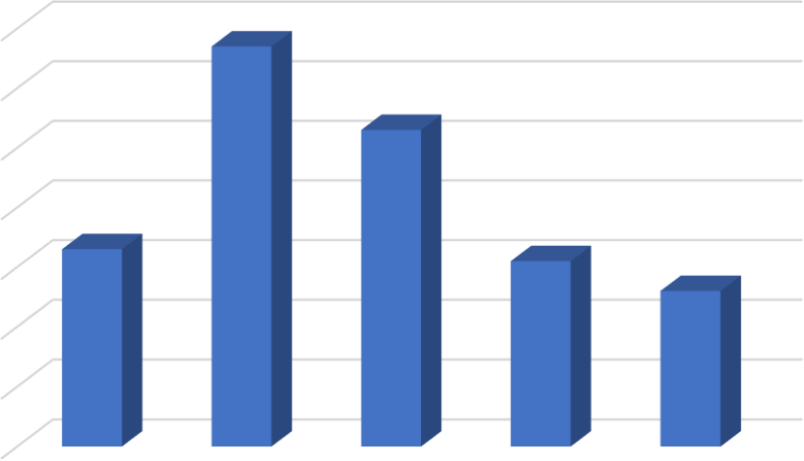

67

70

60

53

50

40

33

31

30

26

20

10

0

Lowest

Low

Neutral

High

Higest

Figure (4.1.6) The above chart represents importance of Time saving

#### Interpretation:

Above chart shows the neural attractiveness towards the time saving factors regarding to frozen food. Mostly people are prefer frozen food to save their time. 25.2% person are gave their neutral response but more than it people are gave the low rank to the time saving factor.

#### Rate of the importance of Taste which influences responders to buy frozen food.

|  |  |  |  |  |  |
| --- | --- | --- | --- | --- | --- |
|  | | Frequency | Percent | Valid  Percent | Cumulative  Percent |
| Valid | Lowe  st | 52 | 24.8 | 24.8 | 24.8 |
| Low | 44 | 21.0 | 21.0 | 45.7 |
| Neutr  al | 61 | 29.0 | 29.0 | 74.8 |
| High | 29 | 13.8 | 13.8 | 88.6 |
| Higes  t | 24 | 11.4 | 11.4 | 100.0 |
| Total | 210 | 100.0 | 100.0 |  |

Table(4.1.7) importance of Taste

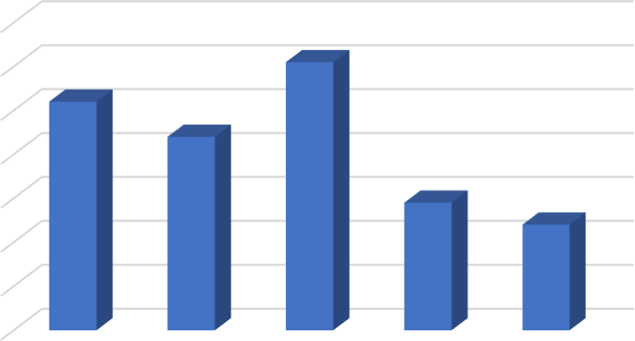

70

61

60

52

50

44

40

29

30

24

20

10

0

Lowest

Low

Neutral

High

Higest

Figure (4.1.7) The above chart represents importance of taste

#### Interpretation:

This chart also as same as above responses. Here also responders are choose the neutral side of the influencing factor of taste. There are some equal response regarding to lowest side. Only 11% responders were gave the highest rank . thus, we can predicted that people are not prefer to taste.

#### Responder used to consume frozen food with some time zone which is mentioned below.

|  |  |  |  |  |  |
| --- | --- | --- | --- | --- | --- |
|  | | Frequency | Percent | Valid  Percent | Cumulative  Percent |
| Valid | Between meals | 56 | 26.7 | 26.7 | 26.7 |
| Breakfast | 53 | 25.2 | 25.2 | 51.9 |
| Dinner | 55 | 26.2 | 26.2 | 78.1 |
| Lunch | 46 | 21.9 | 21.9 | 100.0 |
| Total | 210 | 100.0 | 100.0 |  |

Table(4.1.8) Main time zone of consumption

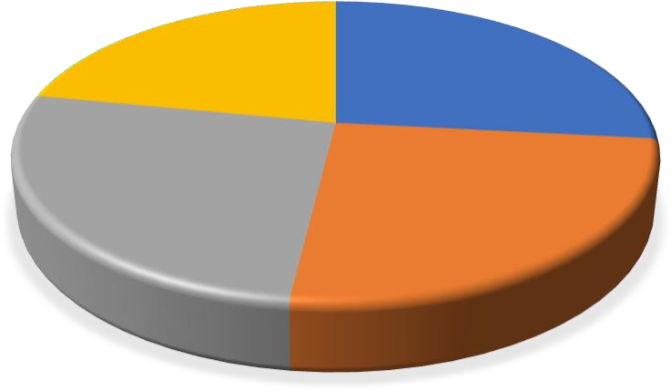

**Lunch**

**22%**

**Between meals**

**27%**

**Dinner**

**26%**

**Breakfast**

**25%**

Figure (4.1.8) Main time zone of consumption

#### Interpretation:

Its seems equal importance in every portion. People are used to consume frozen food at Between meals, Breakfast, Dinner, Lunch similarly. We can say that they are used to consume the frozen food at any time of day. As a dinner and meals ,they are more like to consume the frozen products.

Which brands frozen products people prefers more?

|  |  |  |  |
| --- | --- | --- | --- |
|  |  | Frequency | Percent |
| VALID | ITC | 54 | 18.49315 |
|  | KOHINUR | 42 | 14.38356 |
|  | MTR | 46 | 15.75342 |
|  | AJINOMOTO | 36 | 12.32877 |
|  | McCAIN | 71 | 24.31507 |
|  | NESTLE | 34 | 11.64384 |
|  | AMUL | 9 | 3.082192 |
|  | TOTAL |  | 100 |

Table(4.1.9) Various brands of frozen food

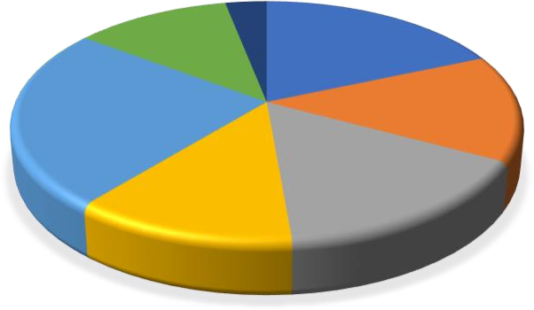

**AMUL**

**NESTLE**

**ITC**

ITC

KOHINUR MTR

**McCAIN**

**KOHINUR** AJINOMOTO

McCAIN

NESTLE

**MTR**

AMUL

**AJINOMOTO**

Figure (4.1.9) Various brands of frozen food

**Interpretation:** This chart includes the major leading company of frozen food. Amul has also number of products but it joined just before 2 year that’s why it has less awareness among the people. According to my research people are mostly used to choose the McCain’s products. Also MTR and Kohinoor has some equal market share from the responders point of view.among the all responder only 3% responders are aware about amul frozen products.

#### The factors that responders liked best about frozen food.

|  |  |  |  |  |  |
| --- | --- | --- | --- | --- | --- |
|  | | Frequency | Percent | Valid  Percent | Cumulative  Percent |
| Valid | Brand name | 48 | 22.9 | 22.9 | 22.9 |
| Packaging  design | 41 | 19.5 | 19.5 | 42.4 |
| Price | 24 | 11.4 | 11.4 | 53.8 |
| Product weight | 40 | 19.0 | 19.0 | 72.9 |
| Quality | 57 | 27.1 | 27.1 | 100.0 |
| Total | 210 | 100.0 | 100.0 |  |

Table(4.1.10) The factors that responders liked best

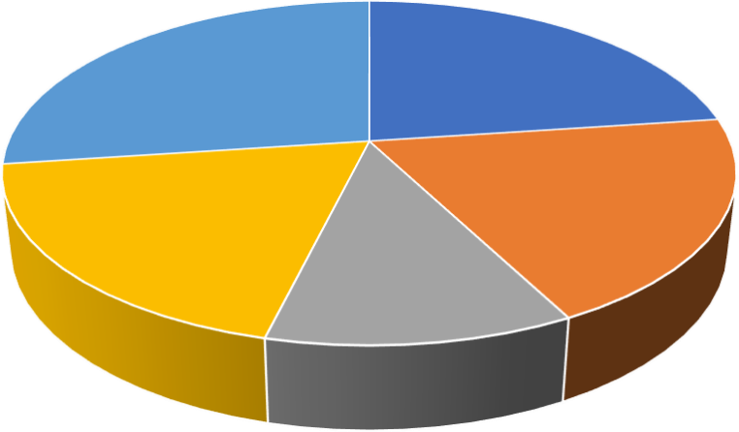

Quality

Brand name

Packaging design

Product weight

Price

Brand name Packaging design Price Product weight Quality

Figure (4.1.10) The factors that responders liked best

#### Interpretation:

Above chart has a main importance in this research because this are the main factors which influence the public to purchase the frozen products. People are must prefer the quality, brand name, and weight of frozen food while choose the various frozen products. According to my research 57 responders are likes the quality factors

regarding to frozen food. There are less responder who don’t like the price of the product.

#### Some types of packaging which is most preferred by consumer.

|  |  |  |  |  |  |
| --- | --- | --- | --- | --- | --- |
|  | | Frequency | Percent | Valid  Percent | Cumulative  Percent |
| Valid | That keep product clean  & untouched | 44 | 21.0 | 21.0 | 21.0 |
| That Keep product in  good condition | 75 | 35.7 | 35.7 | 56.7 |
| That preserve freshness | 36 | 17.1 | 17.1 | 73.8 |
| That Provides better  information or cooking | 55 | 26.2 | 26.2 | 100.0 |
| Total | 210 | 100.0 | 100.0 |  |

Table(4.1.11) Some types of packaging which is most preferred by consumer

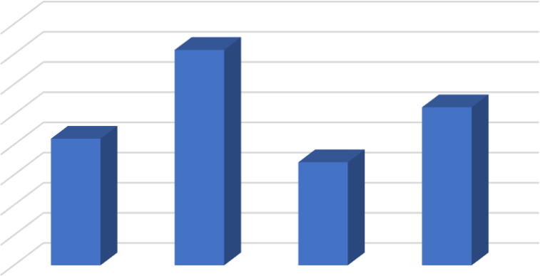

10

5

0

21

17.1

That keep

That Keep

product clean & product in good

That preserve

freshness

untouched condition

That Provides

better information or cooking

Percentage

|  |  |  |
| --- | --- | --- |
| 40 |  |  |
| 35 |  |
| 30 |  |
| 25 |  |
| 20 | 35.7 |
| 15 |  | 26.2 |

Figure (4.1.11) Some types of packaging which is most preferred by consumer

#### Interpretation:

Some types of packaging which are most preferred by responder. Out of them 35% responder are mainly focus on condition of the product which is kept by its

packaging. But people are less focused on freshness of the products there are only 36 responder out of 210 which choose this option. Some people are also influenced by the information which are provided on the package.

#### Type of frozen food product which purchased more time.

|  |  |  |  |  |  |
| --- | --- | --- | --- | --- | --- |
|  | | Frequency | Percent | Valid  Percent | Cumulative  Percent |
| Valid | Desserts | 25 | 11.9 | 11.9 | 11.9 |
| Non veg. | 35 | 16.7 | 16.7 | 28.6 |
| Snacks | 98 | 46.7 | 46.7 | 75.2 |
| Veg /  fruits | 52 | 24.8 | 24.8 | 100.0 |
| Total | 210 | 100.0 | 100.0 |  |

Table(4.1.12) Type of frozen food.



Veg / fruits

25%

Desserts

12%

Non veg.

17%

Snacks

46%

Desserts Non veg. Snacks Veg / fruits

Figure (4.1.12) Type of frozen food.

**Interpretation:** Above chart implies that more number of people are like to consume the frozen food as a snacks and less number of responder are interested in to consume as a desserts. there are 17% of responders who are purchased non veg. frozen food. But same side 25% are also purchased veg/ fruits frozen food products.

#### Reasons behind purchase of frozen food.

|  |  |  |
| --- | --- | --- |
| Reasons | frequency | percentage |
| for travelling | 105 | 33.3333333 |
| for back-up option | 117 | 37.1428571 |
| Time convenience | 93 | 29.5238095 |
|  | 315 | 100 |

Table(4.1.13) Reasons of purchase

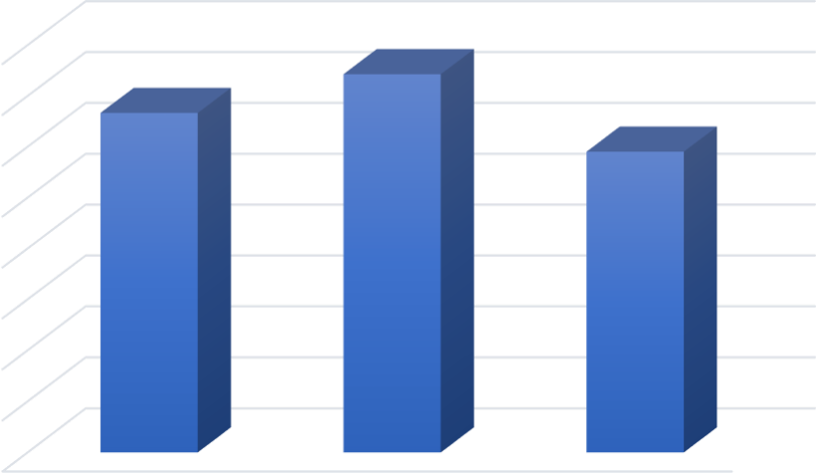

40

35

30

25

20

15

10

5

0

for travelling

for back-up option

Time convenience

Figure (4.1.13) Reasons of purchase

#### Interpretation:

Following chart indicate the in which situation people are used to consume the product. Out of 210 responders there are around 37% people who are use as a backup option, its because of the people’s busy schedule life. People are also liked to consume the frozen products while they are on travelling.93 responder also choose the frozen food as a time convenience.

#### Overall, Satisfaction of people regarding to frozen food while consuming the product.

|  |  |  |  |  |  |
| --- | --- | --- | --- | --- | --- |
|  | | Frequency | Percent | Valid Percent | Cumulative  Percent |
| Valid | Highly  satisfie d | 28 | 13.3 | 13.3 | 13.3 |
| Very satisfie  d | 42 | 20.0 | 20.0 | 33.3 |
| Neutral | 58 | 27.6 | 27.6 | 61.0 |
| Slightly  satisfie d | 40 | 19.0 | 19.0 | 80.0 |
| Not satisfie  d | 42 | 20.0 | 20.0 | 100.0 |
| Total | 210 | 100.0 | 100.0 |  |

Table(4.1.14) level of Satisfaction

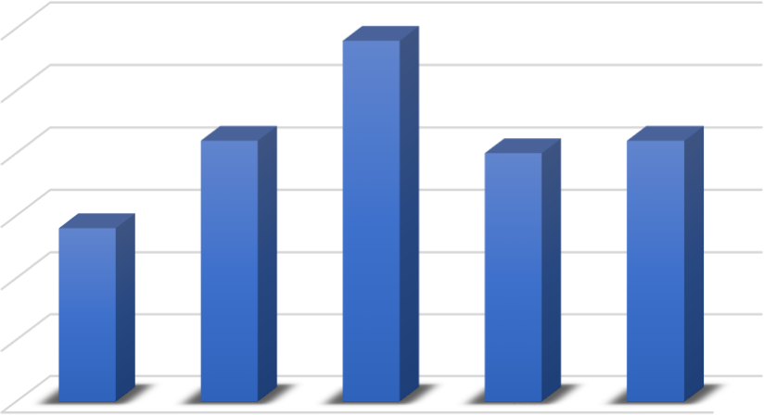

58

60

50

42

40

42

40

28

30

20

10

0

Highly

satisfied

Very satisfied

Neutral

Slightly Not satisfied

satisfied

Figure (4.1.14) level of Satisfaction

#### Interpretation:

From this graph we can say that more number of people are not interested in frozen food. Its because of some loop holl in companys advertisemnet reggarding to products. 58 responders give the netural rate to the satisfaction level. Thus we can say that people are less aware about frozen food or they have less information regardig to frozen food

|  |  |  |  |  |  |
| --- | --- | --- | --- | --- | --- |
| **Age** | | | | | |
|  | | Frequency | Percent | Valid  Percent | Cumulative  Percent |
| Valid | 19-30 | 141 | 67.1 | 67.1 | 67.1 |
| 31-45 | 36 | 17.1 | 17.1 | 84.3 |
| 46-60 | 11 | 5.2 | 5.2 | 89.5 |
| Above 60 | 1 | .5 | .5 | 90.0 |
| Below 18 | 21 | 10.0 | 10.0 | 100.0 |
| Total | 210 | 100.0 | 100.0 |  |

Table(4.2.1) Age

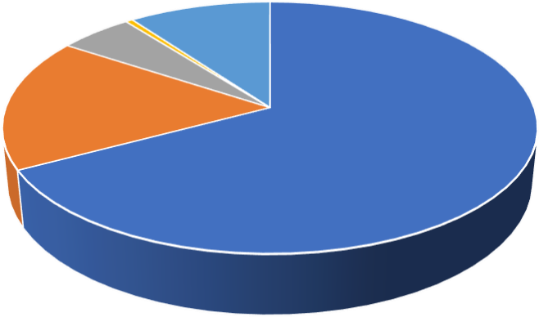

5.20% 0.50%

10%

19-30

31-45

17.10%

46-60

Above 60

Below 18

67.10%

Figure (4.2.1) Age

#### Interpretation:

Most area of chart is covered by under 30 aged people its show large number of young generation are attracted by the frozen food. It can be caused by under this age of people are more connected with advertisement and they are also more involved in social media than other portion of public. Only 0.5% of responder above age 60 are less interested in frozen food .it should be because of health issues. they are still not preferer frozen food as a health conscious.

|  |  |  |  |  |  |
| --- | --- | --- | --- | --- | --- |
| **Gender** | | | | | |
|  | | Frequency | Percent | Valid Percent | Cumulative  Percent |
| Valid | Male | 116 | 55.2 | 55.2 | 55.2 |
| Female | 94 | 44.8 | 44.8 | 100.0 |
| Total | 210 | 100.0 | 100.0 |  |

Table(4.2.2) Gender

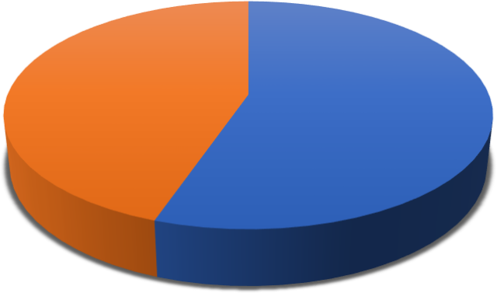

94

116

Male Female

Figure (4.2.2) Gender

#### Interpretation:

The are more male consumer against female. thus we can say that male are use the more frozen food may be because of their busy or a single life. They must not good at cooking that’s why they use the more frozen food.

Qualification

|  |  |  |
| --- | --- | --- |
|  | Frequency | Percent |
| Graduate | 107 | 51 |
| Higher  secondary | 42 | 20 |
| Post  Graduate | 19 | 9.1 |
| Primary | 14 | 6.7 |
| Secondary | 28 | 13.3 |
| Total | 210 | 100 |

Table(4.2.3) Qualification

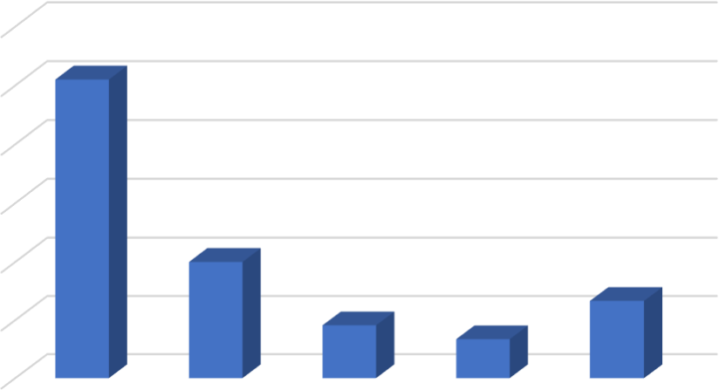

60

51

50

40

30

20

20

13.3

9.1

10

6.7

0

Graduate

Higher

secondary

Post Graduate

Primary

Secondary

Figure (4.2.3) Qualification

#### Interpretation:

According to my research there are more graduate responders I got. Along with I can say that there are number of people under graduate are consumed more frozen products. There are less consumer who are in primary school. There are only 20% of responder which are in higher secondary school and they consuming the frozen food.

#### Income (Per Month)

|  |  |  |  |  |  |
| --- | --- | --- | --- | --- | --- |
|  | | Frequency | Percent | Valid  Percent | Cumulative  Percent |
| Valid | 10,000 to 20,000 | 45 | 21.4 | 21.4 | 21.4 |
| 20,000 to 30,000 | 37 | 17.6 | 17.6 | 39.0 |
| 30,000 to 40,000 | 30 | 14.3 | 14.3 | 53.3 |
| Less than 10,000 | 68 | 32.4 | 32.4 | 85.7 |
| More than  40,000 | 30 | 14.3 | 14.3 | 100.0 |
| Total | 210 | 100.0 | 100.0 |  |

Table(4.2.4) Income (Per Month)



14.3

21.4

32.4

17.6

14.3

10,000 to 20,000 20,000 to 30,000 30,000 to 40,000

Less than 10,000 More than 40,000

Figure (4.2.4) Income (Per Month)

#### Interpretation:

According to my point of view income is less important factor in this research. But whose income is under 10,000 they consumed more frozen foods than other. Peoples, whose incomes are 30 to 40k they have as same as more than 40k income group.

# CHAPTER 5: MAJOR FINDINGS

When we ask respondents that if your particular problems regarding frozen food like high price, poor quality, taste etc., has been solve than will you purchase it?

And most of them were agreed to purchase it. Finally it can be said from the above analysis that people who are unmarried, who live alone and the family in which both husband & wife do the job consume food. Still frozen food makers need to do lot of promotional activities to make people aware about their products and to penetrate the market they also have to reduce the price and maintain the quality of their product.

To identify factors influencing to buying behaviour towards Frozen Food. Such as: Brand name, Packaging design, Price of Product, weight, Quality these are the main factors by which people are more attracted to the frozen food. In this research I found that responder gave the some kind of similar importance to these factors. If any company provides best value to each factors then they can easily grabs the large number of customer.

To evaluate brand preference of the consumers. There are to many companies are manufacturing and selling the frozen food products but I can say they mostly choose the major player of the market regarding to frozen food. They avoid the company which have less trust towards the their products. Mostly people goes to buy the products of company like: ITC, McCain, Kohinoor, Nestle etc.

To analyse which are the most preferred frozen food products. There are mainly two types of products : veg, non veg. both frozen products has some positive growth. Because of taste factor some company expands their various types of frozen products.

**5.1 CONCLUSION**

Frozen food market is the future food shortcut market. in India people being workaholic they don't have time to cook time taking dishes, so they prefer to either go to restaurants or use frozen food market products. The industry hasn't set completely till yet, but it's very soon would be. People are aware about the product but due to one or another reason they are hesitant to use them. The reasons are as follow:

* frozen packets are readily available but many people don't like to have ready products avoiding home food.
* They are good as freshly cooked food but cant be kept for longer period.
* They might cause serious health issues if the manufacturing and expiring dates are not read properly.
* They are little bit costly.

## BIBLIOGRAPHY

The Analysis of Factors Affecting the Buying Interest in Poultry Frozen Food Processed Product

Ratna Purwaningsih, Novie Susanto, Natalia Purba, and Ade Aisyah Arifna Putri

Morwitz, V., Consumers’ purchase intentions and their behavior, Foundation and Trends in Marketing, vol. 7, no

Mullet, E., Age and factors influencing consumer behaviour, International Journal of Consumer Studies, vol. 33, no. 3, pp. 302–308, 2009

[https://www.enotes.com/homework-help/what-factors-affecting-freezing-food-during-](https://www.enotes.com/homework-help/what-factors-affecting-freezing-food-during-336169) [336169](https://www.enotes.com/homework-help/what-factors-affecting-freezing-food-during-336169)

https://wiki.ubc.ca/Course:FNH200/Lessons/Lesson_07

<https://agris.fao.org/agris-search/search.do?recordID=US201300660398>

<https://www.sciencedirect.com/science/article/pii/0140700781901067>

<https://www.ag.ndsu.edu/publications/food-nutrition/food-freezing-guide>

<https://link.springer.com/article/10.1007/s12144-019-00201-4>

## 5.3 ANNEXURE

